
COMSATS University Islamabad
Department of Computer Science

CSC-232 Information Security

Lab # 5

Submitted by: Muhammad Abdullah
Registration Number: (FA24-BSE-042)
Submitted to: Sir Anayat Ullah
Date of Submission: 17 March,2026

LAB 05:
ACTIVITY 1:
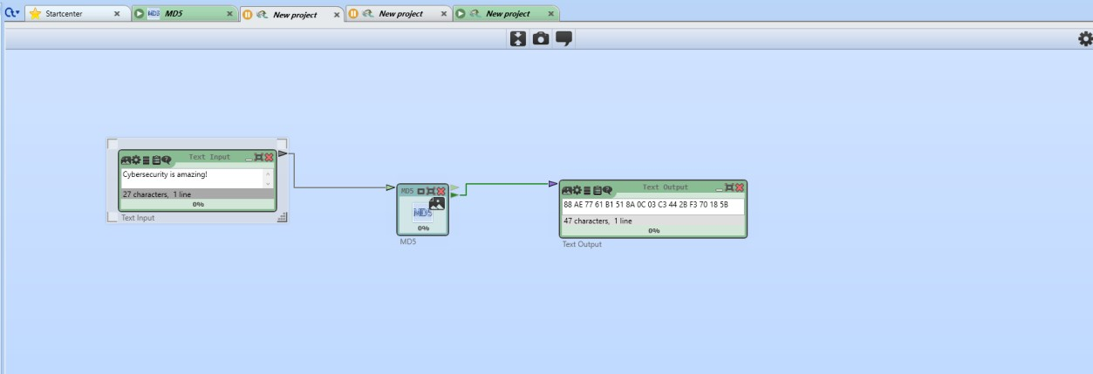

ACTIVITY 2:
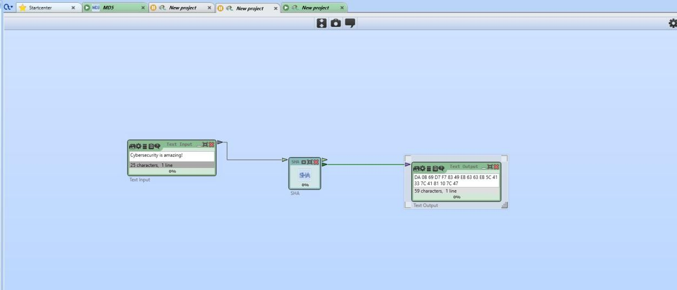

ACTIVITY 3:
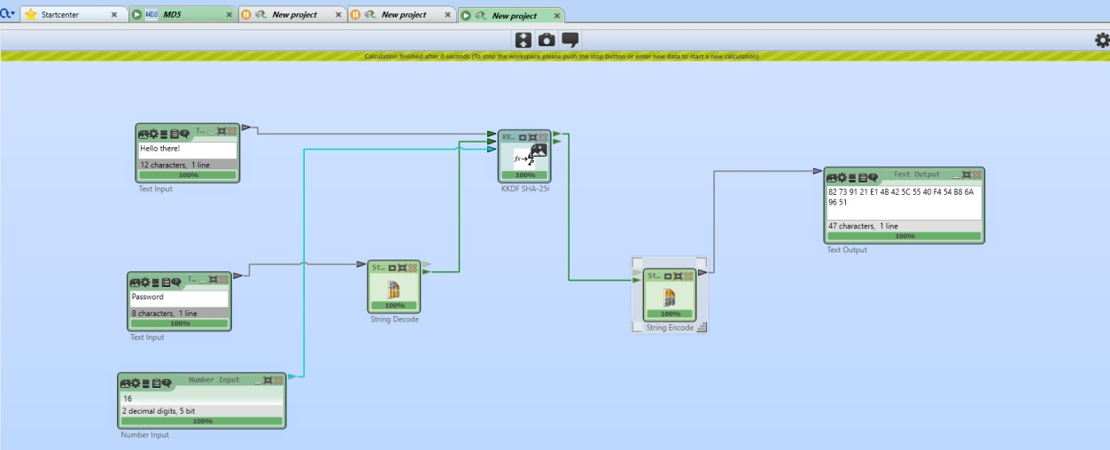
1
.KKDF
-
SHA256 (KEYED KEY DERIVATION FUNCTION)

2. HKDF-SHA256 (HMAC-BASED KEY DERIVATION FUNCTION)
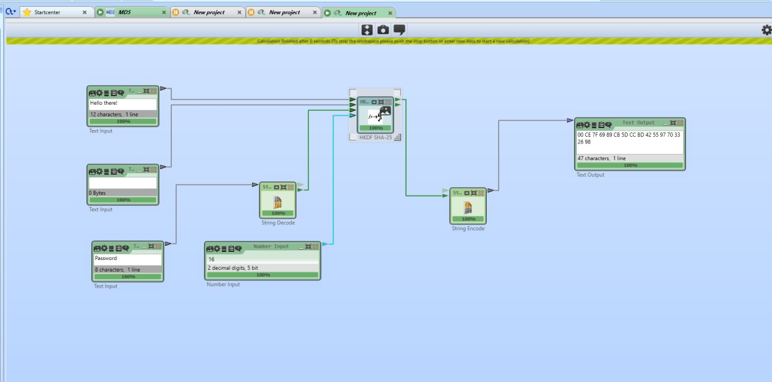
GRADED TASK:
GENERATE AND VERIFY A HASH OF A DOCUMENT USING HASHMYFILES. THE REQUIRED
TOOLS ARE • GPG4WIN (FOR DIGITAL SIGNATURES) • HASHMYFILES (FOR HASHING)
TASK 1:
HashMyFiles online is used to generate and verify file hashes to ensure data integrity.
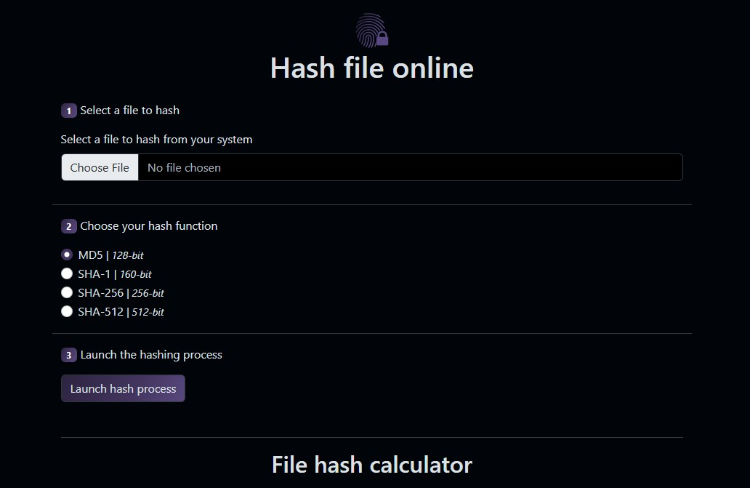
FIRST TEXT:
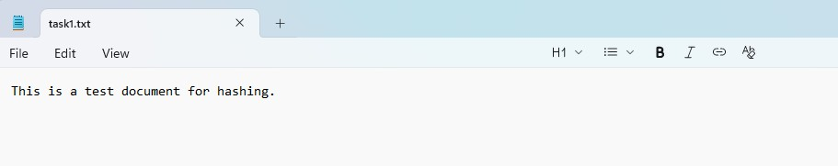

CHANGED TEXT FOR OTHER TASK:
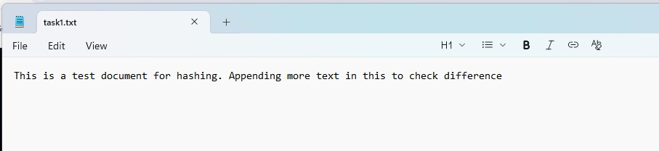
TASK2:
SHA-256 checksums are unique to each file. Even a single change alters the hash completely.

BEFORE CHANGE:
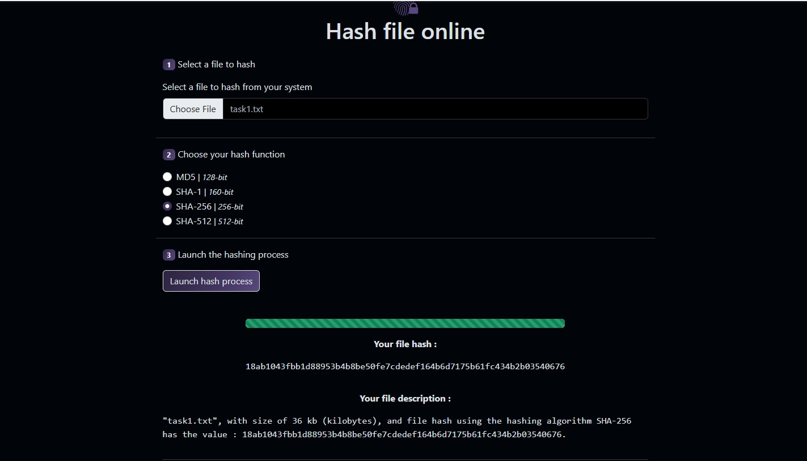

AFTER CHANGE:
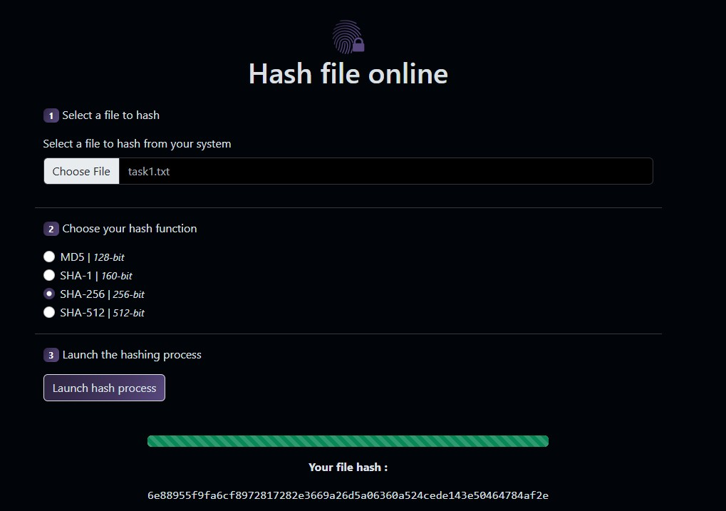
Even minor modifications lead to completely different SHA-256 values.
TASK 3:
MD5 collisions occur when two different files generate the same MD5 hash.
- Downloaded two exe files from the “Peter Selinger: MD5 Collision Demo” website.
- Both files had different text.
- Uploaded both files on HashmyFile website and got same MD5 for both.
- Results are provided below
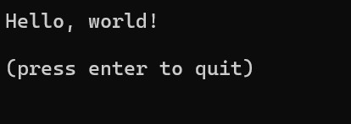
FILE1

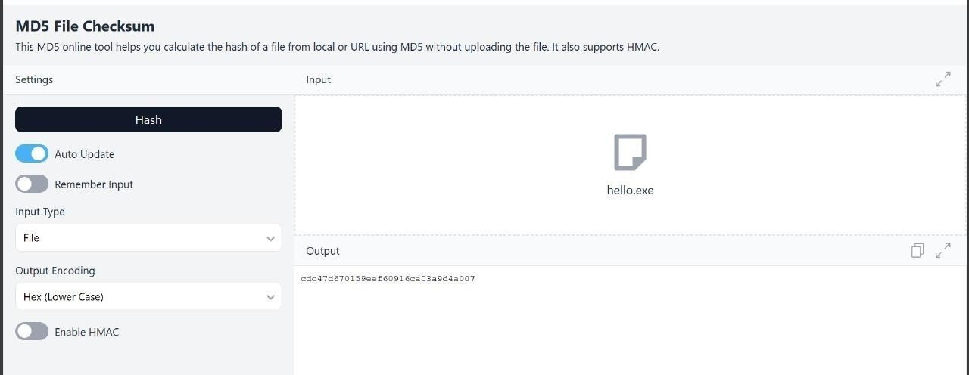

FILE2
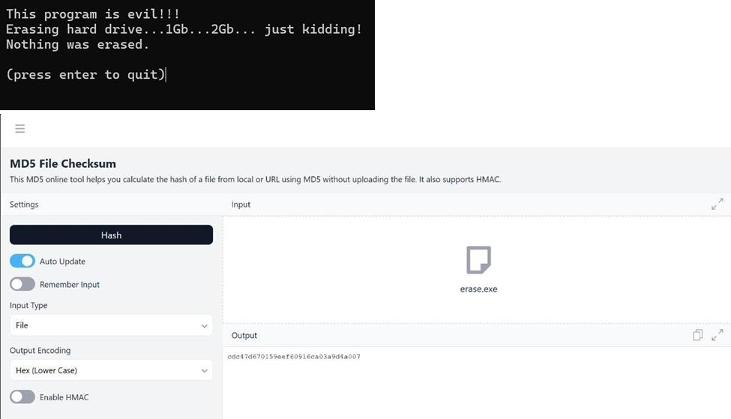

CRYPTOOL2
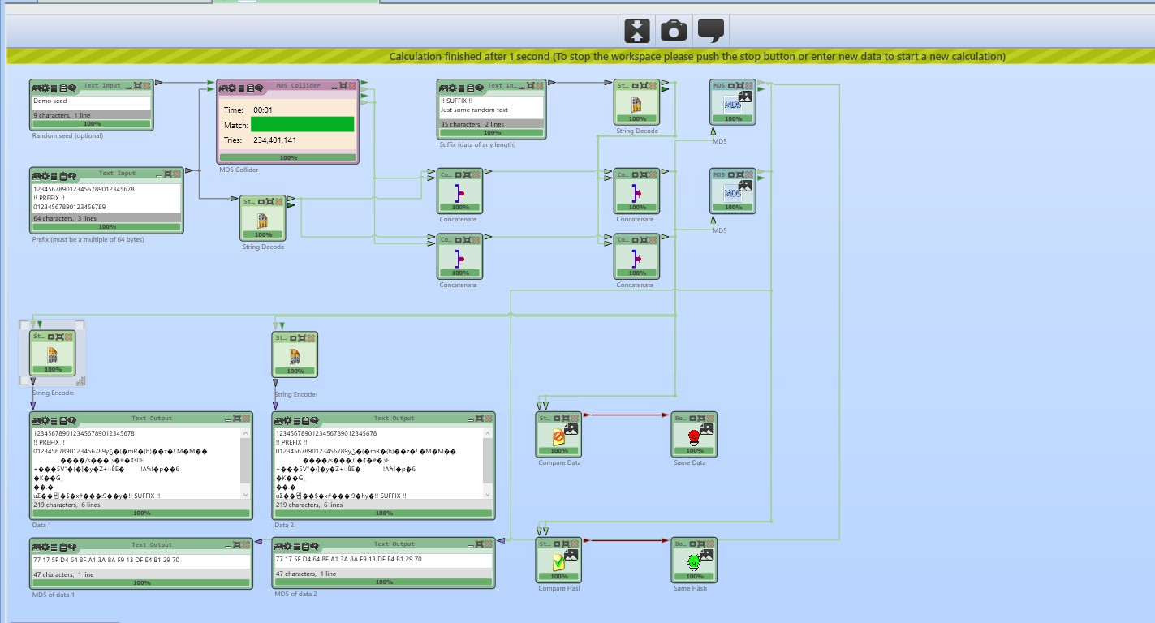
Two distinct files can share the same MD5 digest. This confirms that MD5 is not collision-resistant, illustrating its unsuitability for cryptographic integrity verification.
TASK 4:
Using advanced collision generation, it’s possible to modify files yet maintain identical MD5 values.
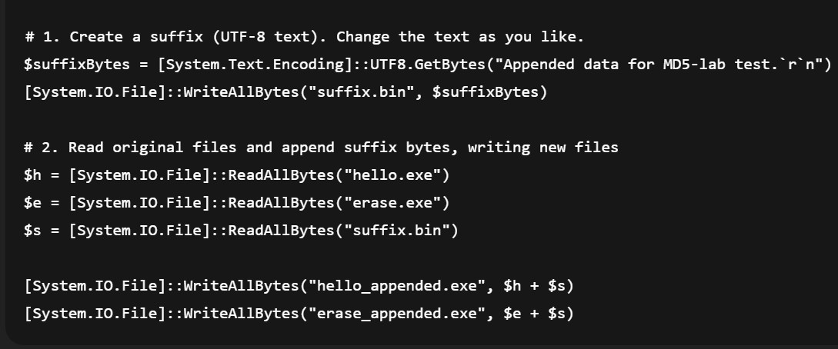
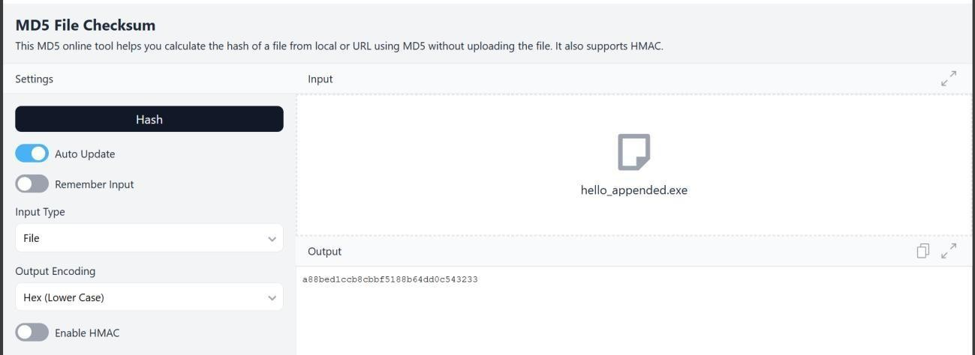
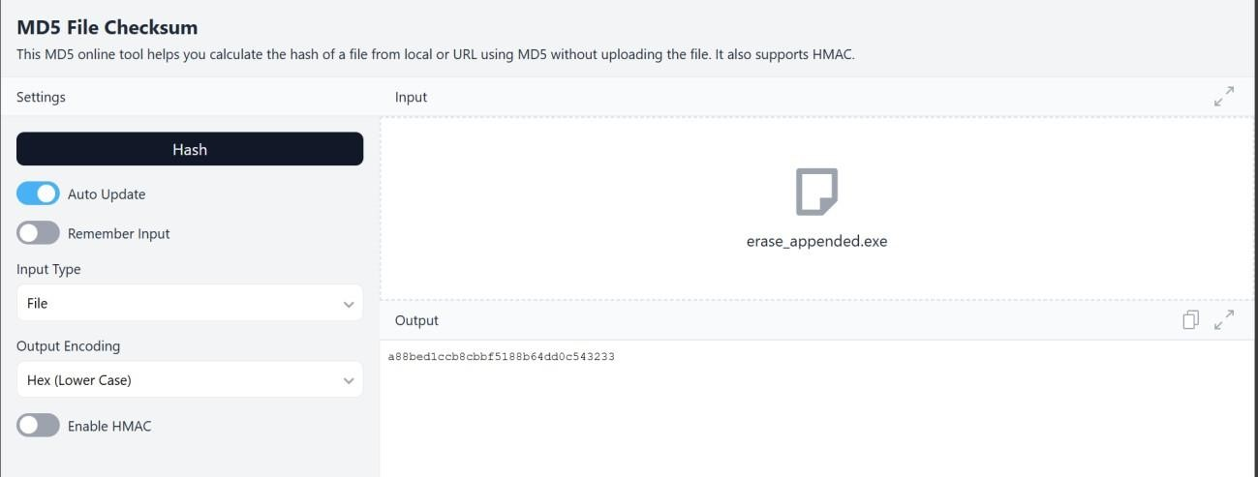

CRYPTOOL2
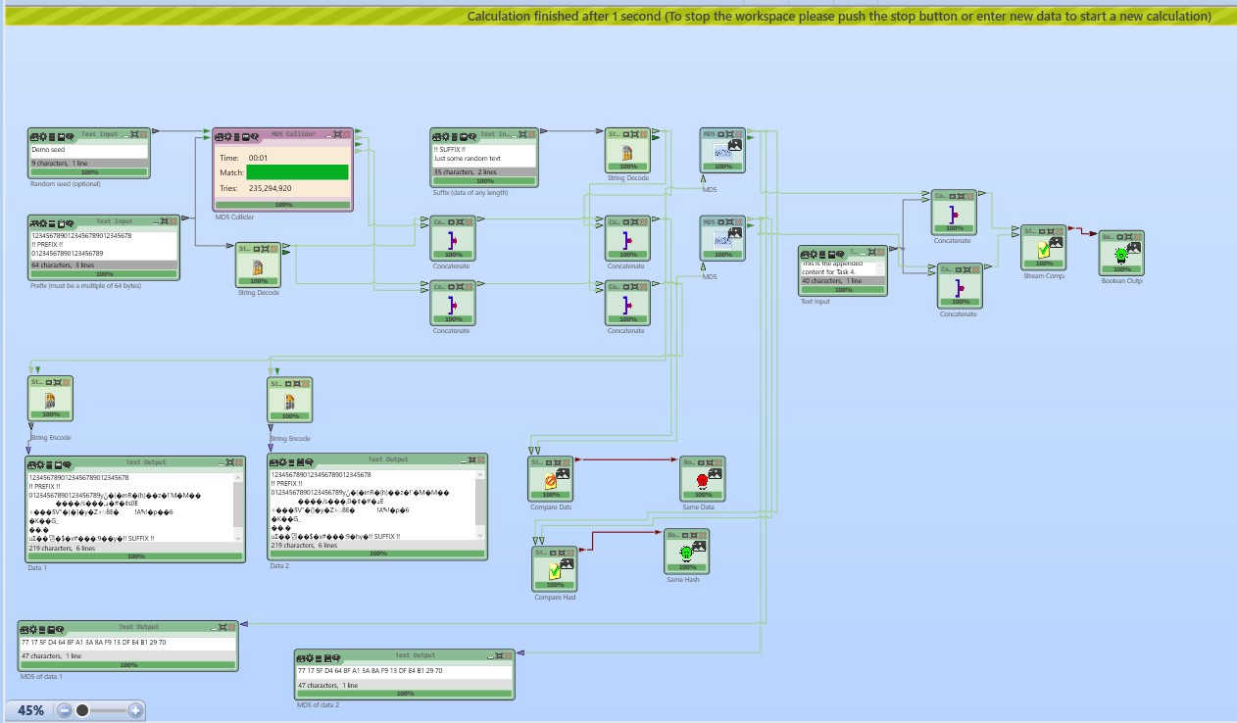
The experiment confirms that:
- MD5 collisions can be generated easily using CrypTool 2.
- Even after appending additional data, the collision remains valid.

